The voyage with national and international epics
All nations in the world has a&nbsp; epic. Our aim is to transmit the epics to the new generation.We want to learn and teach our students national and international epics.We will prepare them the presentations about the epic. At the end of the project, they will know what they are about shortly. they will have awareness about the other nations' epics and also students will learn English and computer applications like voki, canva..
Ulusal ve uluslararası destanlarla yolculuk
Dünyadaki bütün ulusların bir destanı vardır. Amacımız destanları yeni nesle aktarmaktır.Öğrencilerimize ulusal ve uluslararası destanları öğrenmek ve öğretmek istiyoruz.Onlara destanla ilgili sunumları hazırlayacağız. Projenin sonunda, yakında ne hakkında olduklarını bilecekler. diğer ulusların destanları hakkında farkındalık sahibi olacaklar ve ayrıca öğrenciler ingilizce ve voki, canva gibi bilgisayar uygulamalarını öğrenecekler.
PROJE ORTAKLARIMIZ
1-ANNA KOWOSKA/SZKOLA PODSTAWOWA NR 1 W CIESZYNIE/POLAND(POLANYA)
2-Gülşen ÖNBAŞ/ŞEHİT NEBİ GÜNDOĞAN ANATOLIAN HIGH SCHOOL/KIRIKKALE
3-İlknur KASAPOĞLU-KEŞAN SCIENCE HIGH SCHOOL/EDİRNE
4-Merve ÜRER- UNYE ANATOLIAN HIGH SCHOOL/ORDU
5-Mehmet Mutlu TEK-PRIVATE KOÇAŞ ANATOLIAN HIGH SCHOOL/ANTALYA
6-HASAN HÜSEYİN SEVİNÇ-SİMAV GIRLS RELIGIOUS ANATOLIAN HIGH SCHOOL/KÜTAHYA
7-SEÇİL YOZGAT/İBN-İ SİNA VOCATIONA AND TECHNICIAL ANATOLIAN HIGH SCHOOL/AYDIN
8-İSMAİL ERÇETİN/ İBN-İ SİNA VOCATIONA AND TECHNICIAL ANATOLIAN HIGH SCHOOL/AYDIN
9-BERNA KÜN/ İBN-İ SİNA VOCATIONA AND TECHNICIAL ANATOLIAN HIGH SCHOOL/AYDIN
10-HATİCE TOKER/SİVAS ANATOLIAN HIGH SCHOOL/SİVAS

Öğrenciler kullanacakları web 2. O araçlarını sundular.
Kullanıcak web 2.0 araçlarının tanıtımı yapıldı.
https://youtu.be/ISCIVHkBZK8

OKUL TANITIMI YAPTILAR.
https://youtu.be/qR72aoN6lgU
İL TANITIMI YAPILDI.
https://youtu.be/tvnVOwf5rWQ

Padlette öğrenciler kendilerini tanıttılar.

Veli onay belgeleri
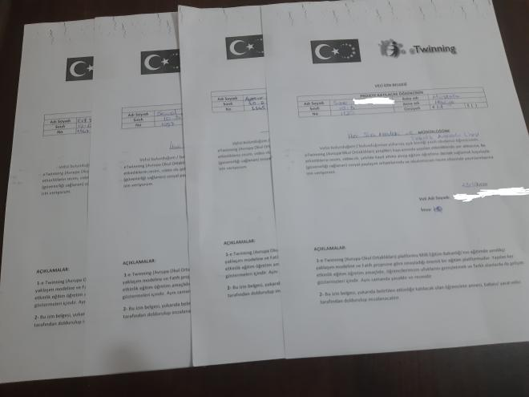

Logo seçimi
Logo seçimi adresinden yapılmıştır.
The Voyage of National and International Epics / Logos (padlet.com)

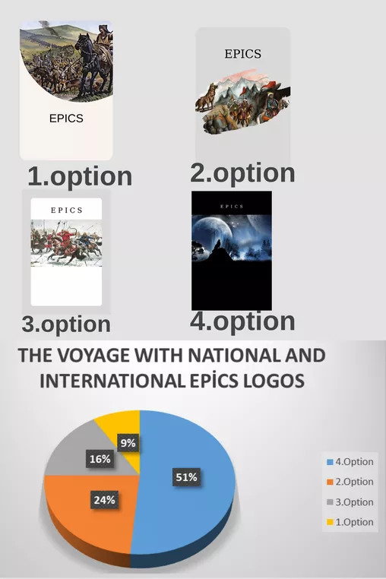

Afiş seçimi yapılmıştır.
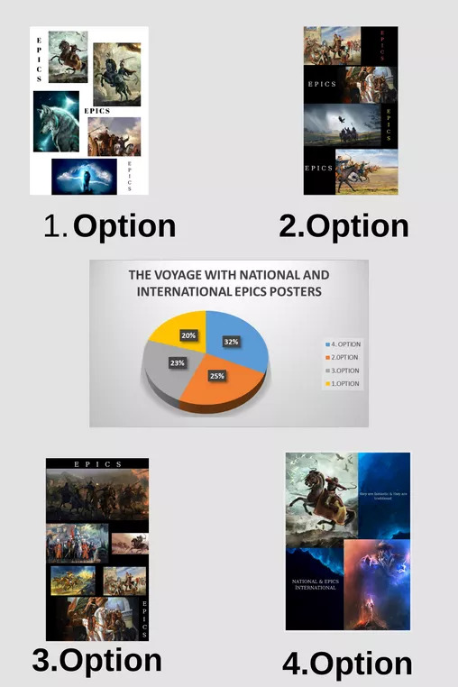

PROJECT PLAN
JANUARY ACTIVITIES
1-Having a meeting about deployment of tasks among the partners about the project
2- Promotion of our city and school via youtube channel
3- Identification of our students and obtaining parent permission documents
4 - Introducing the Web 2 tools we will use in the project (via youtube channel)
5- Introduction of our students (via VOKİ Web 2 tool)
6- Preparing a presentation for our students to have information about the project
7- Determining the logo and poster about the project for our students (with CANVA Web 2 tool)
8- Application of poster survey to our students
9-Watching a secure internet service
10- Applying the beginning of quesionnaires about the project to the students.

FEBRUARY ACTIVITIES

1-February meeting with the project partners
2-Preparation a instagram page of the project.
3-Preparation of the school project board and share it on the school's page.
4-Organizing a competition describing our project
5- Meeting with all members in the project
6- Holding a meeting to explain the project to the parents of the students.
7-Preparing a pre-test for the project.
8-Applying a questionnaire for the schools' logos and posters.
9-Preparation of a presentation of national legend Pan Tadeusz.
10-Preparation of a presentation of national legend "Türeyiş"
11- a presentation of national legend "Yaratılış and Oğuz Kağan"

MARCH EVENTS

1- Meeting with the project partners
2- Contest with web 2 tools (Kahoot) related to the project
3-Preparing a presentation of national legends " Dede Korkut Stories and Ergenekon"
4-Kahoot exam for the epics that the students learned.
5-Preparing a presentation of national legends " Alp Er Tunga and "Türeyiş"

6-Preparing a presentation of national legend " Göç and Seyyid Baddal Gazi"
7-Preparing a presentation of national legend " Köroğlu and Manas.

APRIL EVENTS

1- Meeting with the project partners
2-Preparing a presentation of international legend " Beowolf and İlliada"
3-Preparing a presentation of national legends " Gılgamış"
4-Prepation of presentation of national legends "dante and İlahi Komedya"
5-Applying the end of questionnaire to the students

MAY ACTIVITIES

1- Meeting with the project partners
2-Applying a kahoot exam for the epics that the students learned.
3-Making the final product of the project of e-book for students works.
4-Having a farewell meeting with all members

our works are served on the net until the end of 2024.

PANO

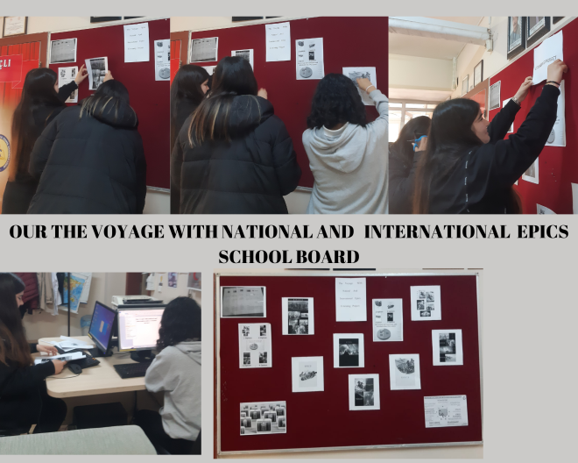

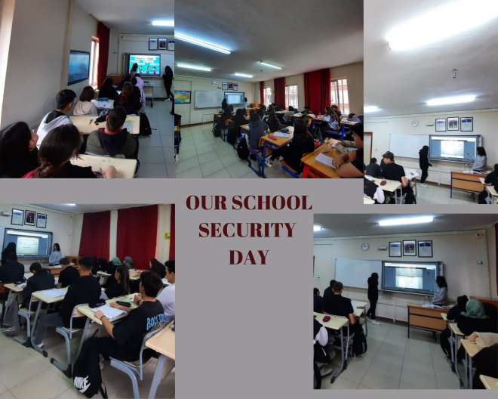

The studies that our students prepared.(Öğrecilerin hazırladıkları çalışmalar )

THE VOYAGE WITH NATIONAL AND INTERNATIONAL EPICS (padlet.com)

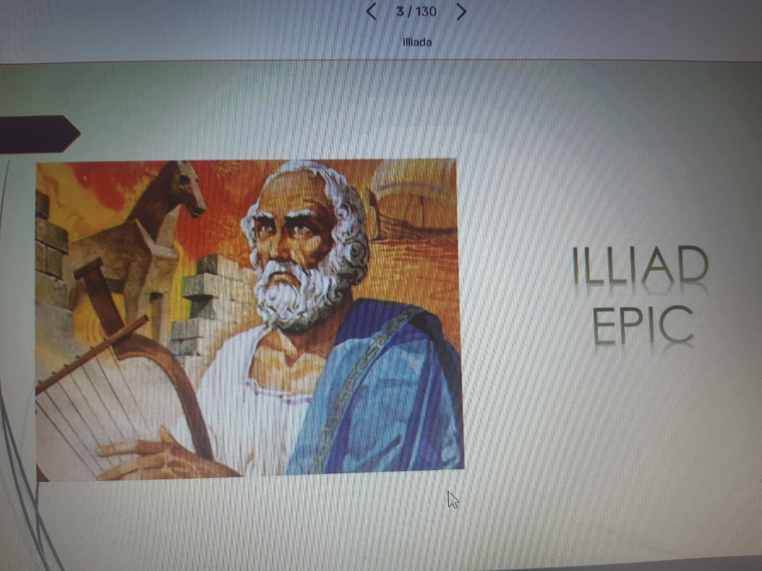
İLLİADA EPİC

THE VOYAGE WITH NATIONAL AND INTERNATIONAL EPICS (padlet.com)

A example from Meeting (Toplantılardan örnek)
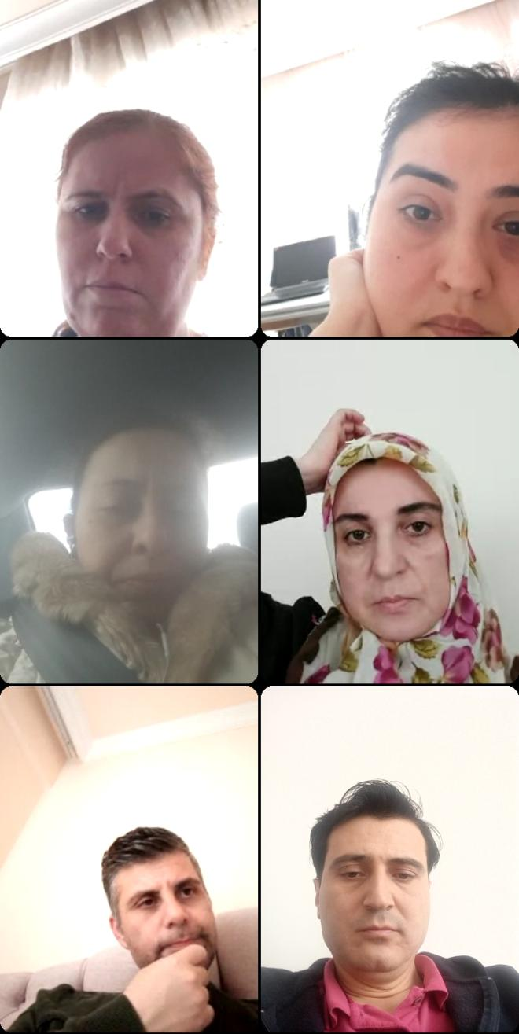

The examples of presentations(SUNUMLARDAN ÖRNEKLERI)

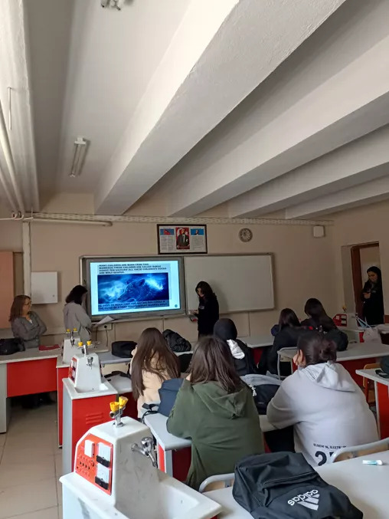

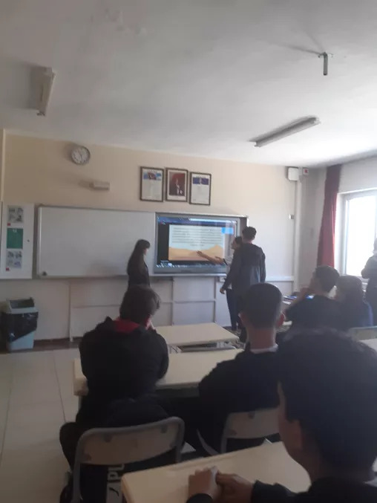

The tquestionnaire for the students at the beginning of the project(Öğrenci ilk test sonuçları)
https://docs.google.com/forms/d/e/1FAIpQLSfpgzOokJx4uTKY8bQXbKJsODx4Xmo6WA5uGcQjmwGSs-mYjw/viewform

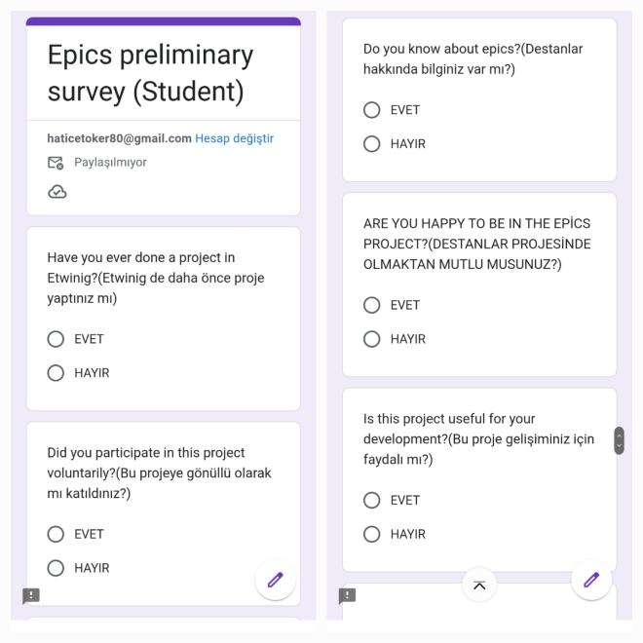
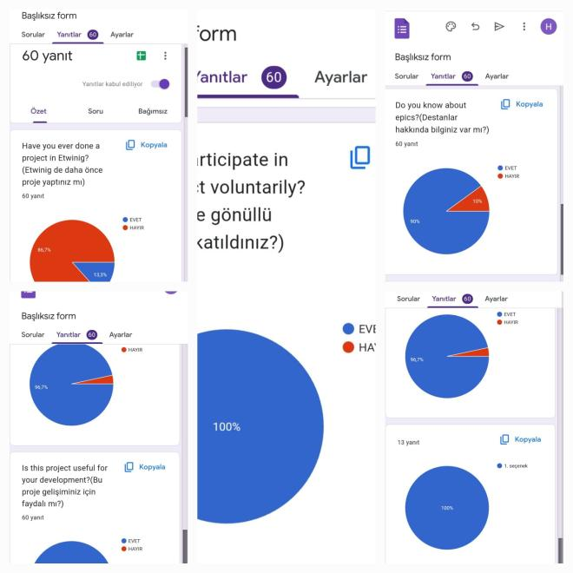

Second test for students:
https://docs.google.com/forms/d/e/1FAIpQLSeHqiqIbZZ6q8x6GsE_1HZPJu9TxyiUBpA6sQOiD5MSy1Wzsw/viewform?usp=sf_link

Öğretmenler için proje başında anket yapıldı.The questionnaire that was done at the beginning of the project.)
https://docs.google.com/forms/d/e/1FAIpQLSeAFyz1YHfohJjxyizS2mDVvrTOn6P3Xpfy0uwxcGGt-mwWvg/viewform

Mehmet Mutlu TEK teacher prepared joint product e-book by using emaze program.
Mehmet Mutlu TEK öğretmenimiz e-maze programı kullanarak ortak ürün hazırladı.
https://www.emaze.com/@ALOTFQFQO/epicsdigital-book?autoplay&hidebuttons

